**Annenberg Center Not Interpolated Old Data**

Learning Regression Tree...

Elapsed time is 0.321313 seconds.

Training RMSE(W): 4.93, R2: 0.818, RMSE/peak: 0.0447, NRMSD: 6.97

Learning a cross validated tree...

Elapsed time is 2.827339 seconds.

Cross Validated Training RMSE(W): 7.44, R2: 0.587, RMSE/peak 0.0674, NRMSD: 10.51

Learning a Random Forest...

Elapsed time is 103.643923 seconds.

Random Forests Training RMSE(W): 5.10, R2: 0.805, RMSE/peak 0.0463, NRMSD: 7.21

Testing RMSE(W): 18.95, R2: 0.000, RMSE/peak: 0.1720, NRMSD: 29.91

Cross Validated Testing RMSE(W): 18.07, R2: 0.000, RMSE/peak 0.1640, NRMSD: 28.52

RF (Testing) RMSE(W): 17.80, R2: 0.000, RMSE/peak 0.1616, NRMSD: 28.10

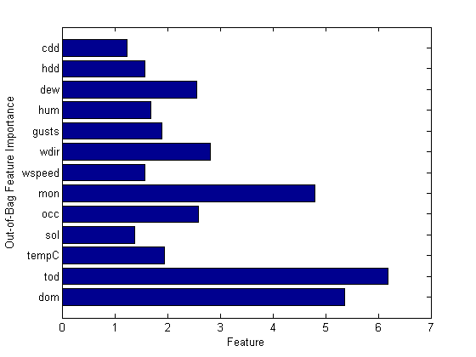

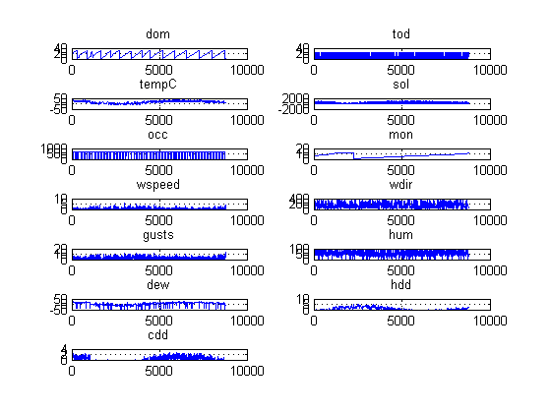

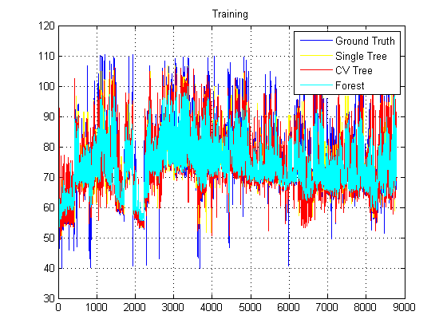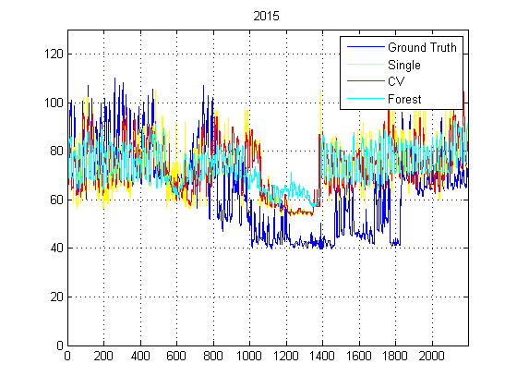

**Annenberg Center Interpolated- Old Data**

Learning Regression Tree...

Elapsed time is 0.855556 seconds.

Training RMSE(W): 5.07, R2: 0.808, RMSE/peak: 0.0459, NRMSD: 7.16

Learning a cross validated tree...

Elapsed time is 3.053368 seconds.

Cross Validated Training RMSE(W): 7.36, R2: 0.596, RMSE/peak 0.0667, NRMSD: 10.40

Learning a Random Forest...

Elapsed time is 93.584754 seconds.

Random Forests Training RMSE(W): 5.09, R2: 0.807, RMSE/peak 0.0461, NRMSD: 7.20

Testing RMSE(W): 18.63, R2: 0.000, RMSE/peak: 0.1691, NRMSD: 29.33

Cross Validated Testing RMSE(W): 17.80, R2: 0.000, RMSE/peak 0.1616, NRMSD: 28.03

RF (Testing) RMSE(W): 17.74, R2: 0.000, RMSE/peak 0.1610, NRMSD: 27.93

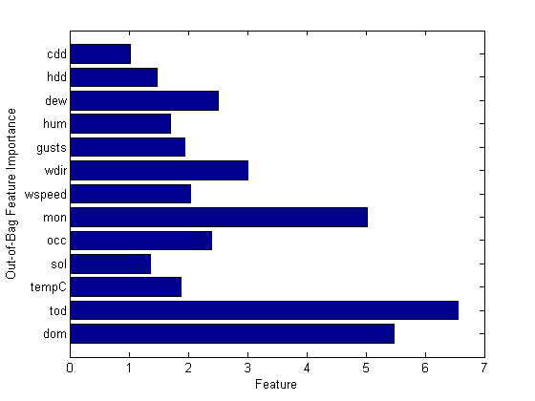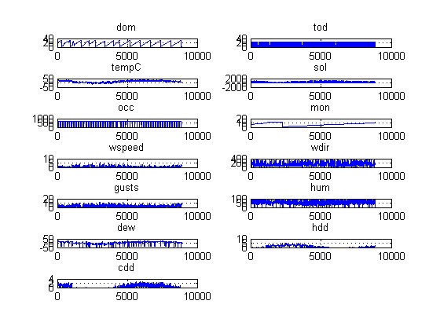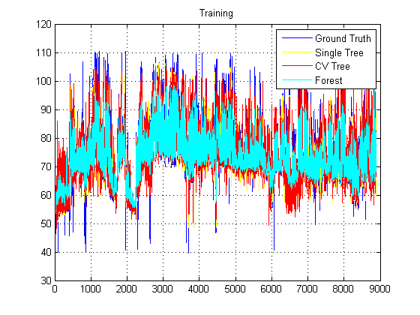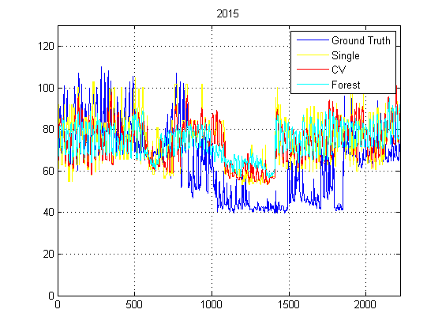

**Annenberg Center- Interpolated New Data**

Learning Regression Tree...

Elapsed time is 0.355050 seconds.

Training RMSE(W): 9.59, R2: 0.865, RMSE/peak: 0.0442, NRMSD: 7.06

Learning a cross validated tree...

Elapsed time is 3.323072 seconds.

Cross Validated Training RMSE(W): 14.83, R2: 0.676, RMSE/peak 0.0683, NRMSD: 10.92

Learning a Random Forest...

Elapsed time is 112.551046 seconds.

Random Forests Training RMSE(W): 10.28, R2: 0.844, RMSE/peak 0.0474, NRMSD: 7.57

Testing RMSE(W): 28.63, R2: 0.000, RMSE/peak: 0.1359, NRMSD: 20.35

Cross Validated Testing RMSE(W): 25.76, R2: 0.000, RMSE/peak 0.1223, NRMSD: 18.31

RF (Testing) RMSE(W): 22.54, R2: 0.000, RMSE/peak 0.1070, NRMSD: 16.02

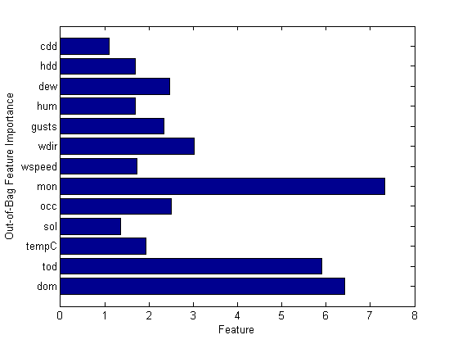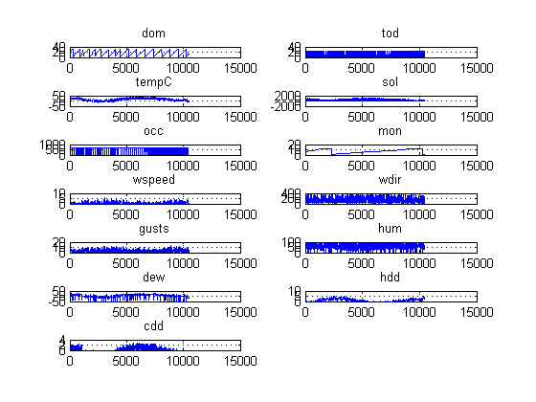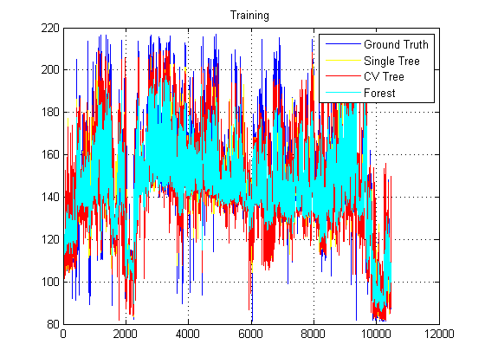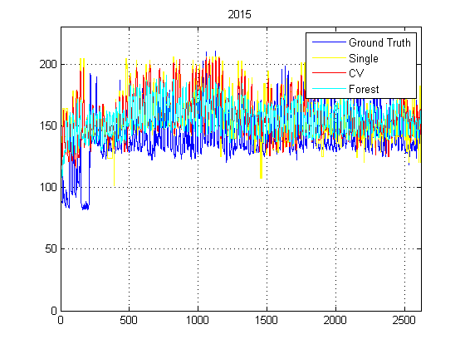

**Annenberg Center Not interpolated New Data**

Learning Regression Tree...

Elapsed time is 0.916571 seconds.

Training RMSE(W): 9.68, R2: 0.863, RMSE/peak: 0.0446, NRMSD: 7.13

Learning a cross validated tree...

Elapsed time is 3.502544 seconds.

Cross Validated Training RMSE(W): 15.05, R2: 0.669, RMSE/peak 0.0693, NRMSD: 11.09

Learning a Random Forest...

Elapsed time is 110.483154 seconds.

Random Forests Training RMSE(W): 10.33, R2: 0.844, RMSE/peak 0.0476, NRMSD: 7.61

Testing RMSE(W): 28.59, R2: 0.000, RMSE/peak: 0.1357, NRMSD: 20.26

Cross Validated Testing RMSE(W): 24.89, R2: 0.000, RMSE/peak 0.1181, NRMSD: 17.64

RF (Testing) RMSE(W): 22.32, R2: 0.000, RMSE/peak 0.1060, NRMSD: 15.82

